Guidelines for Constructing a Syllabus

Items marked with an asterisk (*) are required. Format and style are at the faculty member’s discretion.

General Information
- *Name of university, department
- *Semester, year of course offering
- *Course title, number, credit value
- *Course meeting times, location
- *Course delivery format (if hybrid, fully online, or web-substituted)
- Course webpage URL (if applicable)
Instructor Information
- *Name, academic rank
- *Office hours: times, location
- *Phone number, e-mail address, preferred mode of communication
Course Description
- *Catalog description as found in the TAMU-K Academic Catalog
- Course overview - purpose, rationale
- *Student learning objectives - expected competencies/knowledge/skills upon successful completion
- *Required/recommended textbook/reading materials - author, title, edition, ISBN, retail price (see Textbook Policy webpage)
- *Assignments, assessments - nature and format, requirements, deadlines for submission, dates of assessments
- *Grade assignment - grading procedure, components of final grade and weight assigned to each component
- Prerequisites (if applicable)
- Technology requirements (if applicable)
- Additional materials, equipment (if applicable)
Course Policies
- *Instructor's policies regarding attendance (excused and unexcused absences), tardiness, class participation and decorum, academic dishonesty and misconduct, lab safety (if applicable), cell phone and laptop (or other electronic device) use
- *Instructor's policies regarding late, missing, make-up work, and extra credit
- Information/instructions about submitting student written work to Turnitin, if applicable
- *Instructor’s policies regarding the use of AI technology
Course Schedule
- Sequence and topics to be covered at each class meeting, with required readings and assignments
- Delivery format for each meeting if course is offered as a hybrid class and dates of synchronous meetings for online classes (if applicable)
- Due dates for assignments; dates for exams (including final exam), field trips or other events (if applicable)
- Last day to drop a class
- *Disclaimer - what aspects of the schedule may be subject to change and how changes will be announced

University Policies

*Six Drop Policy
The following provision does not apply to students with Texas public college or university credits prior to Fall 2007. The Texas Senate Bill 1231 specifies the number of course drops allowed to a student without penalty. After a student has dropped six courses, a grade of QF will normally be recorded for each subsequent drop. Additional information on Senate Bill 1231 is available at the Registrar’s Office at (361) 593-2811 and at Academic Procedure: Drop Policy.

*Students with Disabilities
The Americans with Disabilities Act (ADA) is a federal anti-discrimination statute that provides comprehensive civil rights protection for persons with disabilities. Among other things, this legislation requires that all students with disabilities be guaranteed a learning environment that provides for reasonable accommodations of their disability. If you believe you have a disability requiring an accommodation, please contact the Disability Resource Center (DRC) as early as possible in the term at (361) 593-3024. DRC is located in the Student Health and Wellness building at 1210 N. Retama St.

*Classroom Conduct Expectations
Students are referred to the Student Code of Conduct section of the Student Handbook. Students are expected to assume individual responsibility for maintaining a productive learning environment and conduct themselves with the highest regard for response and consideration of others. Ongoing or single behaviors considered distracting will be addressed by the faculty member initially, but if the behavior becomes excessive and the student refuses to respond to the faculty member’s efforts, the issue will be referred to the Dean of Students. In the case of serious disruptive behavior in a classroom, the instructor will first request compliance from the student and if the student fails to comply, the instructor has the authority to ask the student to leave the classroom. The student is expected to comply with the instructor’s request and may subsequently contest this action using procedures established by the department. If the student fails to leave after being directed to do so, assistance may be obtained from other university personnel, including the University Police Department. The incident shall be handled as an academic misconduct matter using established departmental procedures for academic misconduct to determine if the student should be allowed to return to the classroom.

*Academic Misconduct
Students are expected to adhere to the highest academic standards of behavior and personal conduct in this course and all other courses. Students who engage in academic misconduct are subject to University disciplinary procedures. Student are expected to be familiar with the current Student Handbook, especially the section on academic misconduct, which discusses conduct expectations and academic dishonesty rules. Academic dishonesty includes but is not limited to:
- Cheating: deception in which the student misrepresents that he/she has mastered information on an academic exercise that he/she has not mastered; giving or receiving aid unauthorized by the professor on assignments or examinations.
- Aid of academic dishonesty: Intentionally facilitating any act of academic dishonesty. Tampering with grades or taking part in obtaining or distributing any part of a scheduled test.
- Fabrication: use of invented information or falsified research.
- Plagiarism: unacknowledged quotation, and/or paraphrase of someone else’s work, ideas, or data as one’s own in work submitted for credit. Failure to identify information or essays from the internet and submitting them as one’s own work also constitutes plagiarism. Please be aware that the University subscribes to the Turnitin plagiarism detection service. Your paper may be submitted to this service at the discretion of the instructor.
- Lying: deliberate falsification with the intent to deceive in written or verbal form as it applies to an academic submission.
- Bribery: providing, offering or taking rewards in exchange for a grade, an assignment, or the aid of academic dishonesty.
- Threat: an attempt to intimidate a student, staff or faculty member for the purpose of receiving an unearned grade or in an effort to prevent reporting of an Honor Code violation.

Other forms of academic misconduct included but are not limited to:
- Failure to follow published departmental guidelines, professor’s syllabi, and other posted academic policies in place for the orderly and efficient instruction of classes, including laboratories, and use of academic resource or equipment.
- Unauthorized possession of examinations, reserved library materials, laboratory materials or other course related materials.
- Failure to follow the instructor or proctor’s test-taking instructions, including but not limited to not setting aside notes, books or study guides while the test is in progress, failing to sit in designated locations and/or leaving the classroom/test site without permission during a test.
- Prevention of the convening, continuation or orderly conduct of any class, lab or class activity. Engaging in conduct that interferes with or disrupts university teaching, research or class activities such as making loud and distracting noises, repeatedly answering cell phones/text messaging or allowing pagers to beep, exhibiting erratic or irrational behavior, persisting in speaking without being recognized, repeatedly leaving and entering the classroom or test site without authorization, and making physical threats or verbal insults to the faculty member, or other students and staff.
- Falsification of student transcript or other academic records; or unauthorized access to academic computer records.
- Nondisclosure or misrepresentation in filling out applications of other university records.
- Any action which may be deemed as unprofessional or inappropriate in the professional community of the discipline being studied.

*Harassment/Discrimination
Texas A&M University-Kingsville does not tolerate discrimination on the basis of race, color, religion, national origin, age, disability, genetic information, gender, gender identify or sexual orientation (or any other illegal basis) and investigative processes are available for any reports that indicate sexual harassment, sex-based misconduct, harassment, or discrimination may have occurred by a respondent that has enrolled at or is employed with the university. Sexual harassment, sexual assault, dating violence, domestic violence, and stalking based on sex are types of sex discrimination. Such sexual misconduct is unacceptable and will not be tolerated. Any member of the university community violating this policy will be subject to disciplinary action. A person who believes they have been the victim of sexual harassment, sexual assault, dating violence, domestic violence, stalking based on sex or unlawful discrimination of a protected class may pursue either the informal or the formal complaint resolution processes. Reports may be initiated with the Office of Compliance at (361) 593-4758, with the complainant’s immediate supervisor, a department head, a supervisory employee, any faculty or staff, or the Dean of Students at (361) 593-3606. Regardless of who the incident is reported to, the Compliance Office will be notified of the report so that they can reach out to the complainant to discuss supportive measures and administrative processes that may be available.

Please note, all faculty and staff are mandated reporters, except for counselors at Student Health and Wellness. Counselors at Student Health and Wellness are confidential reporters and will not disclose any identifiable information regarding an incident that is made known to them. However, they may be able to provide information on where supportive measures can be obtained and administrative processes initiated. A mandated reporter (any faculty and staff) is required to report any incident that is made known to them, while they are working within their job description, to the Office of Compliance, Lewis Hall, Suite 130, 361-593-4758, titleix@tamuk.edu. This includes incidents that have occurred on or off-campus. For those who wish to remain anonymous and are not reporting a mandated report, anonymous reporting is available at https://secure.ethicspoint.com/domain/media/en/gui/19681/index.html.

*Pregnant and Parenting Students
Texas A&M University-Kingsville does not tolerate discrimination of pregnant or parenting students. Students who are pregnant or parenting may not be denied access to any program or activity on the basis of their pregnant or parenting status. Any pregnant students, or student planning on becoming pregnant, should consult their health care provider to determine what, if any, accommodations are needed, based on their individual situation. Temporary leave for pregnant or parenting students due to medical necessity may also be available. It is the responsibility of the student to communicate their needs to the faculty member or Office of Compliance as soon as possible in order for risk-reduction to be assessed and to determine if additional modifications for the course are necessary. While the university cannot mandate the disclosure of a student’s status as pregnant or parenting, the university strongly recommends that students do provide notification, so appropriate steps can be taken to ensure the health of both the parent and child. To communicate health circumstances or to request additional information (accommodations, leave, lactation rooms, pregnancy parking permits, etc.), the following individuals may be contacted:

Pregnant Students:
Tasha Clark, Office of Compliance, Lewis Hall, Suite 130, 361-593-4758, TitleIX@tamuk.edu

Parenting Students:
Kirsten Compary, Office of the Dean of Students, MSUB, RM 306, 361-593-3606, Kirsten.compary@tamuk.edu

University Support Services

Name | Services
Pathways Academic Assistance Center | - Tutoring and academic support, in-person and online  - Peer Tutors help provide a solid academic foundation that enables students to become confident, capable, independent learners  - Tutors guide students in identifying, acquiring, and enhancing the knowledge, skills, and attitudes needed to reach their desired goals | Location: Jernigan Library, 220  Phone: 361-593-5223  Email: paactutoring@tamuk.edu  Website: PAAC Tutoring  Appointments: javsuccess.tamuk.edu  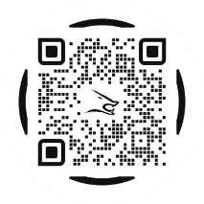  IG: tamuksuccess_squad
Writing Center | - Writing consultation in-person and online  - Writing consultants assist students with writing assignments at any stage of the writing process: understanding assignments, brainstorming, drafting, revising, editing, researching, and integrating sources | Location: Jernigan Library, 217  Phone: 361-593-2744  Email: success@tamuk.edu  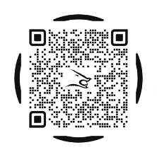  Website: Writing Center
Success Peer Mentoring | - Mentors strive to increase students’ connections with the university & Kingsville community  - Mentors refer students to resources, including experiential learning opportunities (e.g., research, internships, global study, etc.)  - Mentors facilitate student success strategies (e.g., time management, motivation, organization, healthy habits, study/test-taking, etc.) | Location: Jernigan Library, 210 & 242  Phone: 361-593-5800  Email: success@tamuk.edu  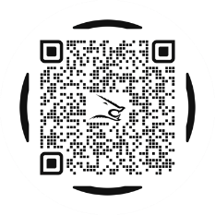  Website: Success Mentoring
Jernigan Library | - Check out books, laptops, calculators, reserve materials and more. (https://libguides.tamuk.edu/access)  - LibGuides provides information concerning online research help for a variety of subjects  - Computer lab on the first floor  - South Texas Archives on the third floor, houses archival materials documenting the rich history of both South Texas and the University | Location: 1050 N. University Blvd.  Phone: 361-593-3319  Email: Ask Us!  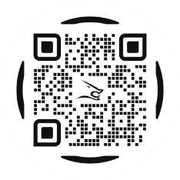  Website: Library
Mental Health & Well-Being | - Provide students with essential knowledge and tools to understand and support mental health.  - Personal counseling focuses on short-term treatment goals to facilitate adjustment, improve functioning, and address acute symptoms that may impede student success  - U-Turn Program helps students identify their academic strengths and opportunities for growth  - Next Steps Career Counseling Program assists students who are unsure of their major, career, or future goals/plans  - After-hours crisis support through UPD 361.593.2611  - Access to Telus Health, a service available 24/7/365 via chat, phone, or webinar. Scan the QR code to download the app and explore the resources available for guidance and support whenever it is needed. | Location: 1210 N. Retama St.  Phone: 361-593-5080  Email: counselingservices@tamuk.edu  Website: Counseling  Suicide & Crisis Lifeline: call/text 988  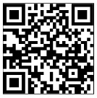  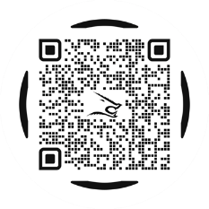  Telus app
Disability Resources | - Ensure equal access and full participation in the college experience and programs for students with disabilities  - Facilitate reasonable academic accommodations for students on a case-by-case basis that aid in academic success | Location: 1210 N. Retama St.  Phone: 361-593-3024  Email: drc.center@tamuk.edu  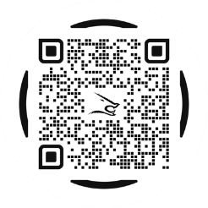  Website: Disability Resource
Advising | - Advisors ensure students stay on track to meet their degree plan needs  - Help students set and reach academic and personal career goals  - Assists students in finding educational opportunities & campus resources | Location: Various Locations  Phone: 361-593-3935  Email: success@tamuk.edu  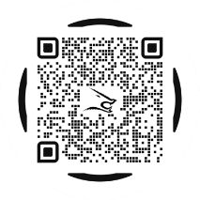  Website: Academic Advising
Career Engagement | - Resume reviews & practice interviews  - Strategic career & alumni mentoring connections  - Work study & on-campus job-finding assistance  - Internships & full-time jobs in Javelina Careers powered by Handshake  - Career Expos | Memorial Student Union Building (1050 W. Santa Gertrudis Ave.),  122 (across from Starbucks)  Phone: 361-593-2217  Email: hirejavelinas@tamuk.edu  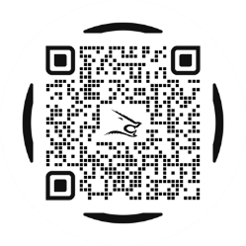  Website: Career Engagement

