Changing Addresses and Phone Numbers
On Blue & Gold
Step by Step Viewing Process
Texas A&M University-Kingsville

JNET to Blue & Gold to Main Menu
1
Go to jnet.tamuk.edu and sign in using your ku ID and university password. Click on Academic Records then on the far right side of your screen under Personal Information Click on Update Addresses and Phones.
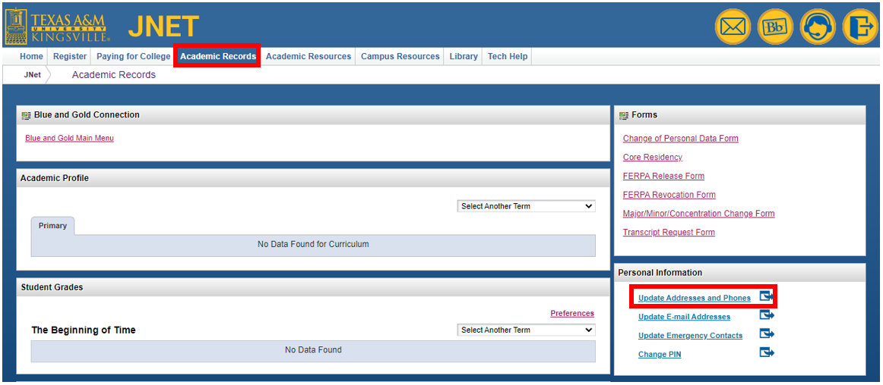
2
Adding Addresses and Phone Numbers
If you are creating a new address, or wish to add an address click on the Type of Address to Insert Box and select the type of address you would like to edit. Then click Submit. Hint: With every Address Type you can add a phone number as an additional contact. This is how you can update your phone number for the University to contact you.
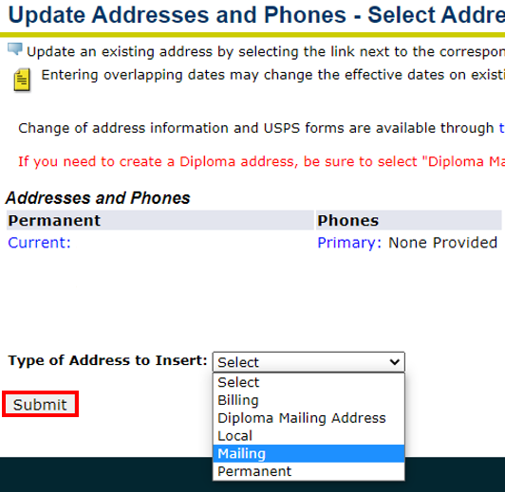
After you click submit, you will be able to fill insert the address and phone number. When you are done filling out the boxes and everything looks correct click Submit.
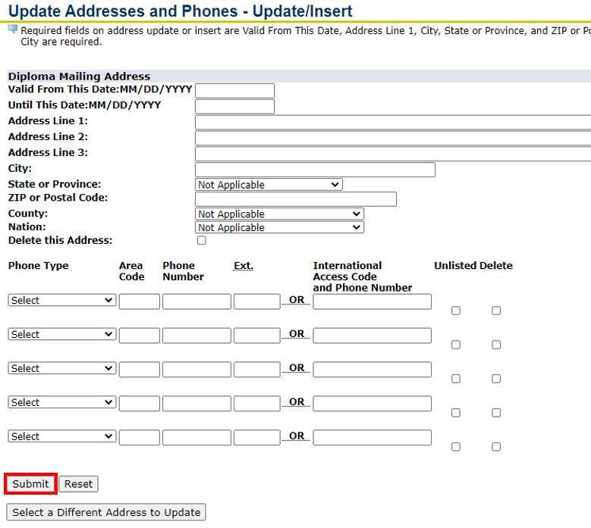
3
Updating Addresses and Phone Numbers
If you wish to update your address click on the Current hyperlink next to the address. Select the box that you wish to change and edit. Once you are done editing or adding to the address, click Submit to save the information.
