Holds User Guide
With Additional Hold Types and Explanations
Step by Step Viewing Process
Texas A&M University-Kingsville

Blue & Gold
1
Go to jnet.tamuk.edu and sign in using your ku ID and university password. Click on Academic Records and then on Blue and Gold. This will open up on the Blue and Gold’s Main Menu.
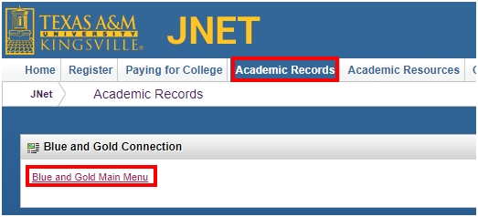
Once on the Blue and Gold Main Menu click on Student and Financial Aid.
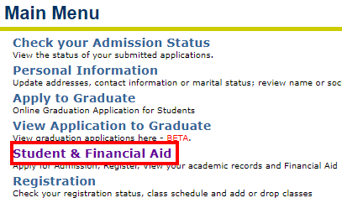
2
Student & Financial Aid Menu
On the Student and Financial Aid Menu there will be a lot of options, but to view the holds you will need to click on Student Records.
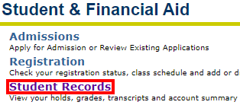
Student Records
3
On the Student records menu click on View Holds.
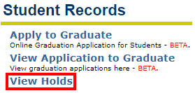
After Clicking on View Holds you will either see the hold(s) listed or a message stating there are no holds in your account.
If you do have a hold it might look like this:
If the ‘To Date’ has 99 at the end of the year. That hold will not be lifted until the department from the University is contacted for further information.
What the hold enables you from doing. Examples may be registering for classes or unable to order official transcripts.

Department to Contact for the Hold
Name of the Hold
Reason for receiving the hold

Holds will keep you from registering from classes and/or ordering a transcript. It is important for you to contact that department to be able to lift the hold for the student’s account.

Below is a list of possible holds any student may have with the definition and the coordinating department to contact about that hold.

Hold Types and Explanations:

The following is not a complete entire list of possible holds, but the most common. Please follow the instructions to get the specific hold removed. Contact you Academic Advisor for any holds you are unsure about.
Admissions Office Holds
For more information please contact the Admissions Office 361-593-2315 or emailing admissions@tamuk.edu
- Admission File Incomplete – Documents missing. This is more than likely what you will see if you are missing a transcript
- Meningitis Acknowledgement Hold – Meningitis Information needs to be submitted.
- TSI Hold – Needs TSI Scores - Student is missing TSI scores. Student must sign up for TSI assessment to be able to register for next semester. Contact advisor at 361-593- 4376 if you have any additional questions.
Athletics Holds
For more information please contact your coach & Hannah Lantz at (361)593-2155
- Student Athlete – CURRENT student athletes you must speak with your coach & Hannah Lantz
Business Office Holds
For more information please contact the Business Office 361-593-2616 or emailing moneyconnect@tamuk.edu
- No Financial Agreement - The Financial Responsibility Agreement must be accepted before the student is allowed to register for the semester. Please see the Financial Responsibility Agreement for details.
  - Upon signing into Blue and Gold for the first time prior to orientation, students will be provided with some information about their responsibility for taking care of payment arrangements. Once the student acknowledges it, then the hold will be removed.
- Financial Hold (Previously Over $500) - Placed after semester emergency/book loan and deferred payment plan payment deadlines. Will prevent registration for subsequent semesters and Official Transcript releases until the balance is brought below $500. Placed in conjunction with FH holds.
- Financial Hold (Previously Below $500) - Placed after semester emergency/book loan and deferred payment plan payment deadlines for ANY amount. Will prevent registration for subsequent semesters and Transcript releases until the balance is paid in full.
- Transcript Hold Only - Has been replaced by FH (Financial Hold) for clarity.
- Perkins Loan Hold - Placed on student account when a Perkins Loan has been obtained. Used for Business Office Information only and DOES NOT prevent registration for subsequent semesters or Official Transcript releases.
- Perkins Loan Delinquent - Placed on past due Perkins Loan Accounts. Will prevent registration for subsequent semesters and Official Transcript releases until the balance is paid in full.
- Payment at Business Office only - Placed on accounts when a payment has been returned as uncollectible for various reasons (i.e. Non-Sufficient funds, Closed Accounts). Will only prevent online payment ability until resolved.
- Title IV Recalculation Requirement - Placed on student accounts upon withdrawal from the university. Allows time for Financial Aid recalculation to determine if student will owe back any federal financial aid funds. Will prevent registration for subsequent semesters and Official Transcript releases for a short period after withdrawal. Removed with Financial Aid approval.
- Collection Agency Hold - Placed on accounts that have been assigned to a Collection Agency for severely past due balances. Will prevent registration for subsequent semesters, Official Transcript releases, and online payment ability. Payments also cannot be made online or in the Business Office and must be resolved with the Collection Agency to which it has been assigned.
- State Hold - Placed on accounts for Outstanding Balances with either Texas A&M University Kingsville or any other State Agency. This hold alone DOES NOT prevent registration or Official Transcript releases.
  - If the debt is not with Texas A&M University Kingsville, the student must personally contact the Texas State Comptroller's Office at 1-800-531-5441, ext 34561, option 2. Please listen to all menu options in case this has changed.
  - Due to privacy regulations, Texas A&M University Kingsville does not know the Originating Agency, the reason for the hold, or amount of the debt, and cannot inquire about this hold on behalf of the debtor.
Center for Student Success Advisor
For more information please contact your Advisor through your college. (You can search for them on the tamuk.edu using the search engine at the top right side of the screen.)
- See Advisor – See College Advisor
- No Web Registering’ See Advisor – First semester transfers and freshmen MUST see you academic advisor. See Student Success Advisor
- “Academic standing prohibits registration”- Your institutional GPA is under 2.0; you may wait until grades post to see if you are over 2.0; sit out a semester if your GPA remains under 2.0, or begin Enforced Withdrawal Appeal Process.
- “See Advisor: Advising for under 30-45 SCH”- You must be advised by your academic advisor.
Health and Wellness
For more information please contact the Health and Wellness Office 361-593-3991 or emailing jcastillo-alaniz@tamuk.edu
- Meningitis Immunization Requirement – BMEN Vaccine and/ or Meningitis Record Needed
- Bacterial Meningitis Notification- The State of Texas has mandated Bacterial Meningitis information be provided. Upon signing into Blue and Gold, students will be provided some generic information about Bacterial Meningitis and a link to a website regarding the disease. To proceed with registration, students must check a box and click submit, which will acknowledge that they have received the information.
Office of International Student & Scholar Services
For more information please contact OISSS (361)593-3317 or emailing oisss@tamuk.edu
- International Student Orientation Hold - New international students need to contact OISSS at OISSS@tamuk.edu or by phone at 361-593-3317 to have hold temporarily lifted until they can complete the orientation. Students will not be able to register for classes until this is taken care of with OISSS.
- Proof of Insurance Hold - New international students need to contact OISSS have hold temporarily lifted. Students will not be able to register for classes until this is taken care of with OISSS.
- Check-in with OISSS - New students are to either email OISSS or call them to have this hold cleared.
Registrar’s Office
For more information please contact the Registrar’s Office (361)593-2811 or emailing registrars@tamuk.edu
- Meningitis Waiver – The State of Texas has mandated Bacterial Meningitis information be provided. However an exception is given to students who are registering ALL of their classes online only.

