The Social Hall located at the Javelina Student Engagement Center is a room available for all student organizations to hold different types of events. The room can comfortably sit 70 people using round tables, 30 people using testing tables, and sofas that can sit 20 others. The Social Hall also offers a projector and a big screen TV for meetings, socials, or presentations. To book the Social Hall please follow the steps below:

1. Visit https://www.aaiscloud.com/TXAMUKingsville/Default.aspx and click on “Calendars”

2. Make sure that the time and date of the event you want to request is available on the Javelina Student Engagement Center calendar and then click on “Request Event”

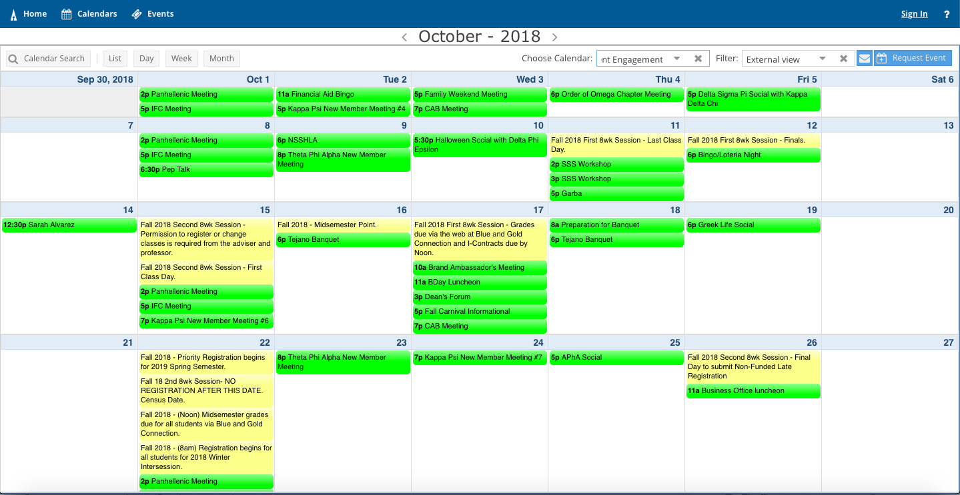

3. Select the “Javelina Student Engagement Center”

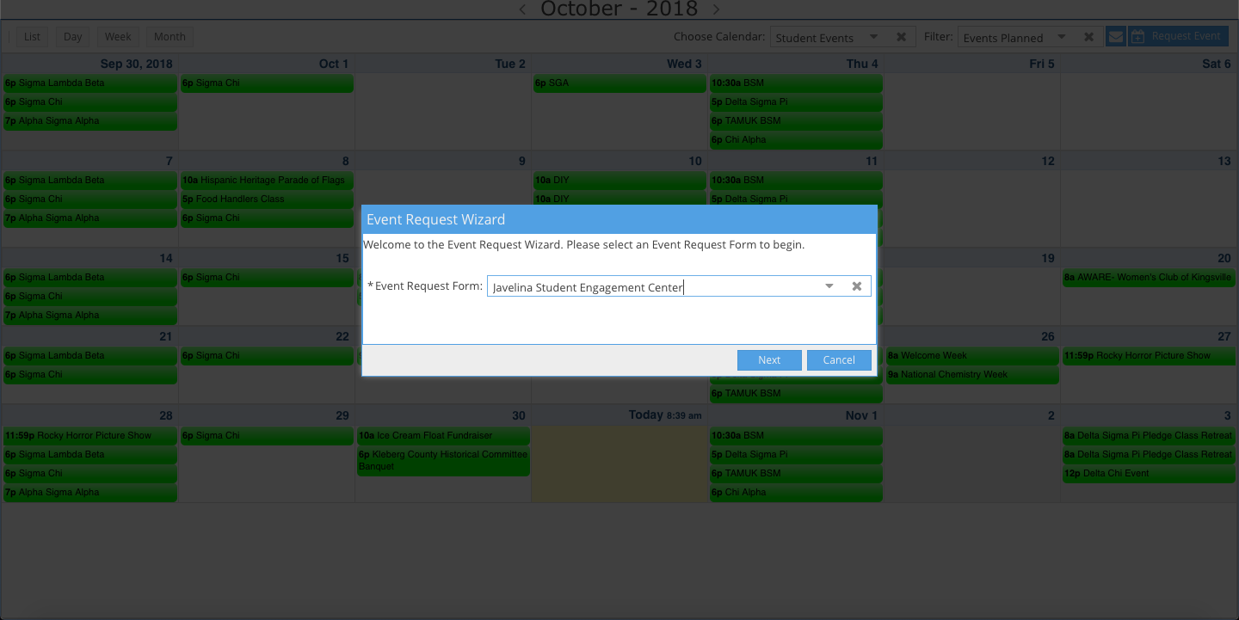

4. Fill out all of the boxes accordingly
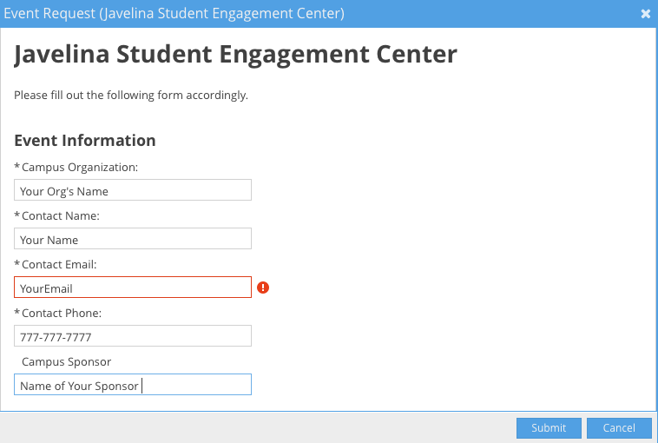

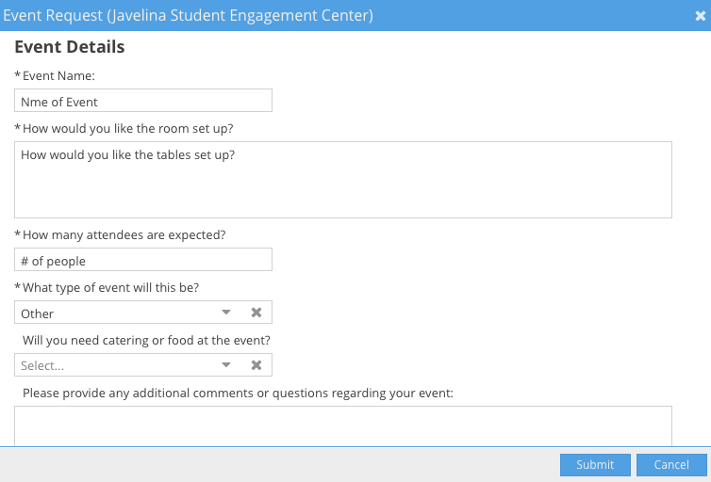

5. After you fill out all of the boxes press the “Add Meeting” button.

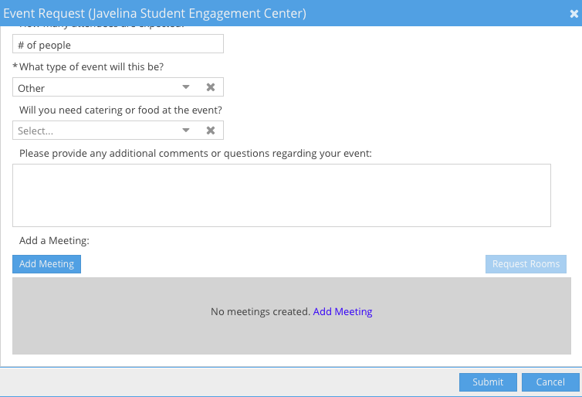

6. Add the time and date of your event, then click on “Add Meeting”

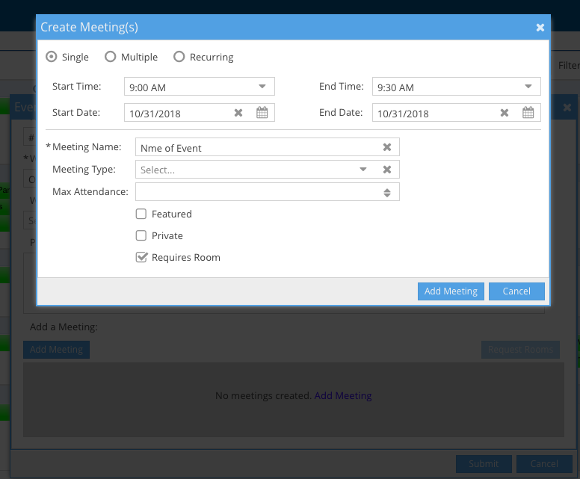

After you add the meeting, press the Submit button and then you are done creating the request.

Requesting the Social Hall doesn’t guarantee you the space. You will receive an email confirmation or denial within 2 business days. Please keep in mind the Javelina Student Engagement Center reservation guidelines at all times.

